Sorrow comes in great waves...but it rolls over us, and though it may almost smother us. It passes and we remain." - Henry

jatasya hi dhruvo mrtyur dhruvam janma mrtasya ca
tasmad apariharye'rthe na tvam socitum arhasi
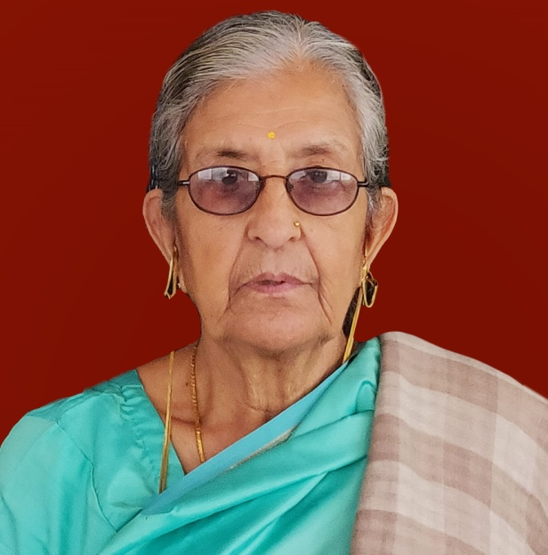
With profound grief we inform the sudden sad demise of Lt Mohini Dhar (Pushpa ji) Wife of Lt Shri Poshkar Nath Dhar (original resident of Sheshyar,HabbaKadal) on 8th Feb 2019, presently residing at Faridabad .Not only were you a great sister, devoted wife, caring mother, a loving grandmother, a great social & religious person but also a passionate , courageous & pious human being. You touched everyone’s heart with your exceptional love and affection. You were a fountainhead of love and care who taught us what real values were and your life reflected it. You never distinguished between anyone whether it was a close one or stranger and loved them and respected them in all ways. You were very active and fast in every sphere of life , Alas- you showed same pace while departing the body and flew within half an hour without giving trouble to any one of us. Being an active member of Kashmiri Sewak Samaj,you served with dignity and always working towards the betterment of Samaj and kashmiri biradri.We will miss your presence and the cherish able moments spent with you. Your strength & fondness will be inspiration for us. You were our guide and gave us directions in our traditions which you were very particular..You always mingled easily with others from all walks of life, engaged them in discussions . You always shared a great bond with children having great affection towards them.. We will never forget those precious moments with you. You made us feel special by celebrating both our small and big success which we owe to your blessings. We know the life will move on but will always miss you. But we have so many wonderful memories to hang on to. Your love will carry us through to the end of days. We love you.
GRIEF STRICKEN:
Mrs Pammi & Mr Anil Dhar (Daughter in Law & Son)
Mrs Indu & Dr Anoop Bangroo(Daughter & Son in Law)
Mrs Sonali & Mr Vivek Dhar ( Grand Daughter in Law & Grand Son)
Mr Abhishek Dhar,Mr Akshay Bangroo & Ms Apoorva Bangroo ( Grand Children)
Samast Dhar & Kotru familyHouse No. 58,Sector 16,Faridabad,M:9910383512,8826249848,9818953697

